Connor Johnson

CS 1675

Assignment 5

1. (b) Predictions are the columns and actual are the rows

**Test Data**

|  |  |  |
| --- | --- | --- |
|  | Positive | Negative |
| Negative | 121 | 40 |
| Positive | 22 | 46 |

The model error on the test data was 27.07%

Sensitivity = 0.6765, Specificity = 0.7516

**Training Data**

|  |  |  |
| --- | --- | --- |
|  | Positive | Negative |
| Negative | 263 | 76 |
| Positive | 89 | 151 |

The model error on the training data was 30.61%

Sensitivity = 0.555, Specificity = 0.7758

(e)

Test Error

|  |  |  |  |  |
| --- | --- | --- | --- | --- |
|  | 0.05 | 0.2/sqrt(k) | 0.05/k | 2/sqrt(k) |
| 4000 epochs | .2969 | 0.2140 | 0.2140 | 0.2664 |
| 500 epochs | .2969 | 0.2140 | .2140 | 0.2751 |
| 2000 epochs | .2969 | 0.2140 | 0.2140 | 0.2707 |

Training error

|  |  |  |  |  |
| --- | --- | --- | --- | --- |
|  | 0.05 | 0.2/sqrt(k) | 0.05/k | 2/sqrt(k) |
| 4000 epochs | .2913 | 0.2301 | .2301 | 0.3024 |
| 500 epochs | .2913 | 0.2301 | .2301 | 0.3340 |
| 2000 epochs | .2913 | 0.2301 | .2301 | 0.3061 |

The best performing models are when the number of epochs is higher and when alpha is equal to 0.2/sqrt(k) or 0.05/k. This is true for both the test and training data.

2.1

(b)

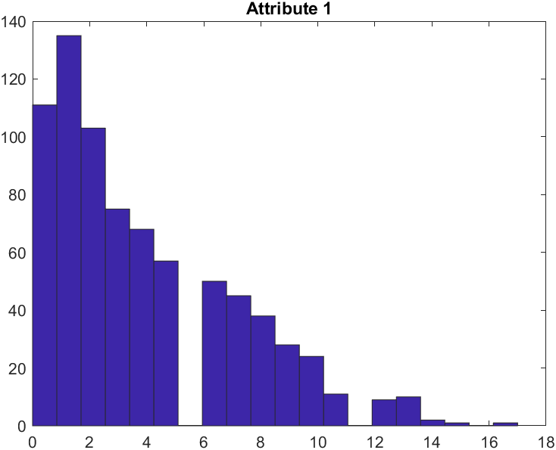 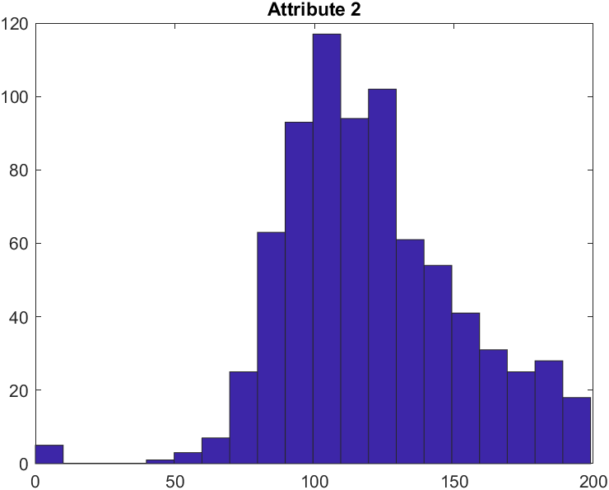

Gamma Distribution Gamma Distribution

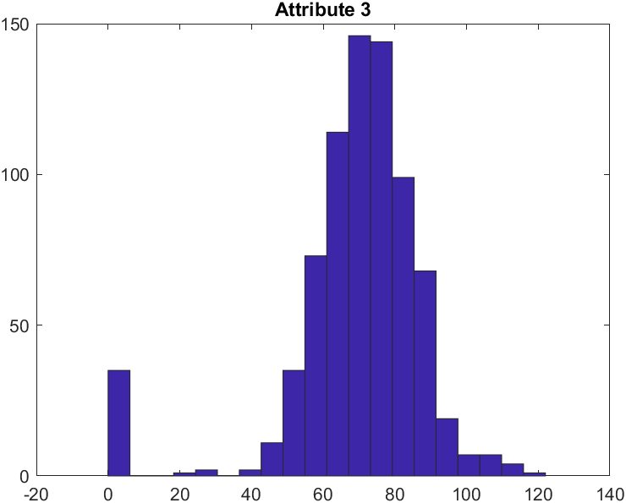 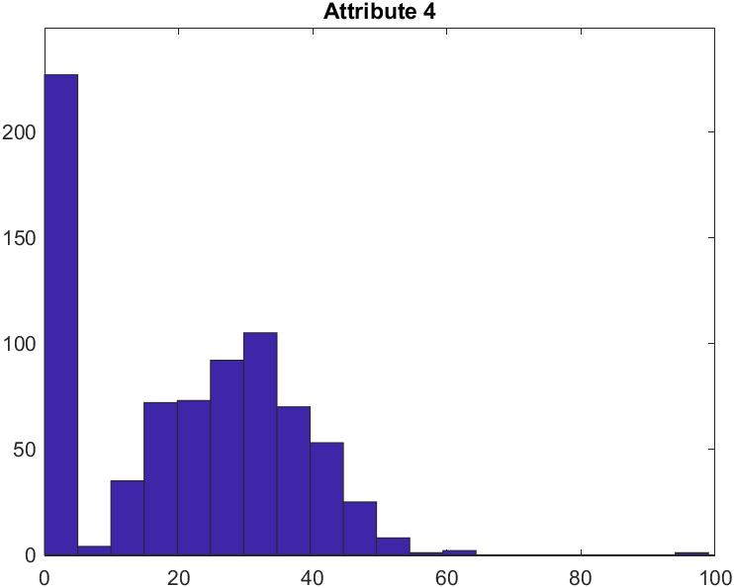

Binomial Distribution Multinomial distribution

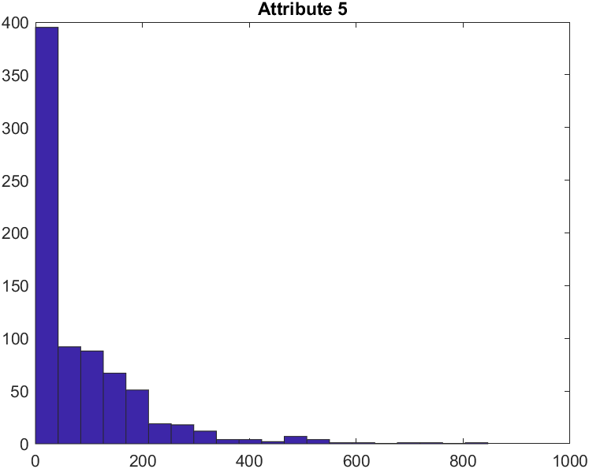 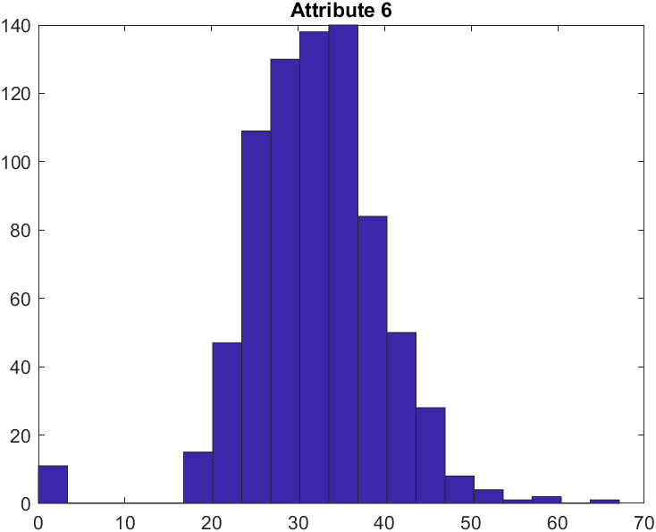

Exponential Dist. Normal Distribution

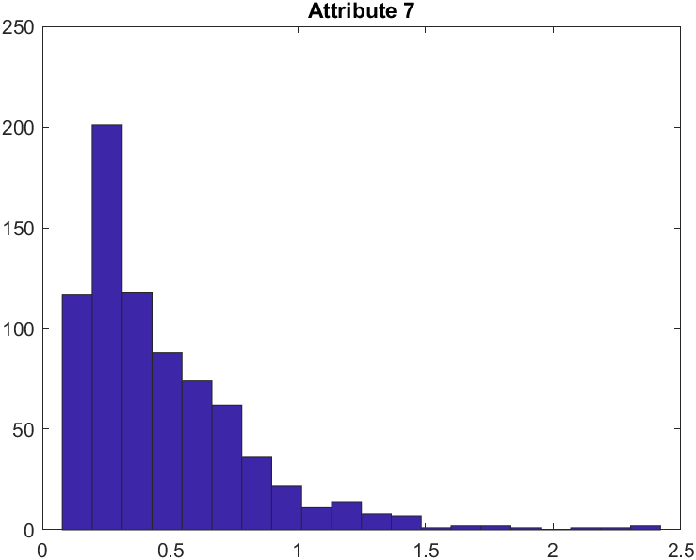 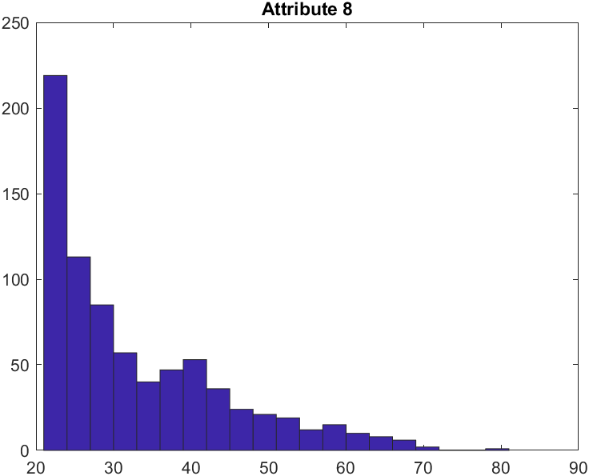

Gamma Distribution Exponential Distribution

2.2b Blank sigma means it’s an exponential distribution

|  |  |  |  |  |
| --- | --- | --- | --- | --- |
|  | Class 0 mu | Class 0 sigma | Class 1 mu | Class 1 sigma |
| Attribute 1 | 3.2419 |  | 4.71 |  |
| Attribute 2 | 109.6254 | 26.2304 | 141.395 | 33.6655 |
| Attribute 3 | 67.5339 | 18.6683 | 70.19 | 21.6213 |
| Attribute 4 | 19.7316 | 14.5828 | 22.935 | 17.8275 |
| Attribute 5 | 67.7168 |  | 103.72 |  |
| Attribute 6 | 30.3059 | 7.7258 | 35.258 | 7.3286 |
| Attribute 7 | 0.4164 |  | 0.5491 |  |
| Attribute 8 | 31.1032 |  | 37.12 |  |

2.3b

Predictions are the columns and actual are the rows

**Test Data**

|  |  |  |
| --- | --- | --- |
|  | Positive | Negative |
| Negative | 119 | 42 |
| Positive | 18 | 50 |

The model error on the test data was 26.2%

Sensitivity = 0.7353, Specificity = 0.7391

**Training Data**

|  |  |  |
| --- | --- | --- |
|  | Positive | Negative |
| Negative | 235 | 104 |
| Positive | 48 | 152 |

The model error on the training data was 28.2%

Sensitivity = 0.76, Specificity = 0.6932

(c)

Overall, the naïve bayes model performs slightly better than the logistic regression. The regression only works when alpha is set to certain values which could just be because of the data we have. Both models have very similar specifities on the test set. The bayes model performs better because of its higher sensitivity. This shows that the bayes model is better at predicting positives when compared to the logistic model.